BLG411E Software Engineering

Project Plan

**Socialendar**

13.10.2017

Socialendar team

Yunus Güngör

Sinan Kartal

Mustafa Sağlam

Mehmet Enes Kayılıoğlu

Recep Can Babaoğlu

**1.Introduction**

1.1 Scope

The Socialendar application can bring together people who will same events efficiently, easily and precisely. These people are using mobile phone calendar and this app brings together these people in a chatroom if they want. User only need to login to add a new event or to edit current events. Then application take users in a chat room and provide users a communication channel. Users can sign up and sign in with Facebook, Google and mail accounts and application will take their events from device calendar or Facebook. The Socialendar is a JavaScript based application that uses React-Native for mobile phones which have iOS and Android. The application will interface with and utilize third party resources to facilitate all the users’ meeting scheduling needs (e.g. database services, email communication, etc.).

1.2 Deliverables

|  |  |
| --- | --- |
|  | Deliverables |
| 1 | Login to app with Facebook |
| 2 | Login to app with Google |
| 3 | Login to app with Email |
| 4 | Device calendar and cloud database synchronization |
| 5 | Assigning chat groups to user events and chatting with users who has same events on their app |
| 6 | Showing next free time of the user |
| 7 | Ability to add events |
| 8 | Ability to view events |
| 9 | Ability to view chat |
| 10 | Showing weather status for event time and location |
| 11 | Adding an event through app to database and device calendar |
| 12 | Facebook calendar sync, device calendar and cloud database synchronization |

1.3 Epics

|  |  |  |
| --- | --- | --- |
| No of Epic | Epic | Explanation |
| 1 | UI | All of user interface, and interactions with any visible item on screen |
| 2 | Database | Connections to Firebase Database (explained in resources), synchronization between device calendar, facebook events and online database |
| 3 | Device Calendar | Accessing to device calendar, adding and editing events on device calendar |
| 4 | Chatting | Chatting between users |
| 5 | Event Matching | Matching user’s events on online database with other users’ events on online database. |
| 6 | Users and login systems | Logging in, signing up, logging out and signing up with other social accounts like Facebook and Google |
| 7 | General Structure | General structure based on react-native framework, libraries and react-native modules |

1.4 Non-functional Issues

|  |  |  |
| --- | --- | --- |
| Number of issue | Non-functional Issue | Explanation |
| 1 | Usability | Usability will be a big problem in this project since our team doesn’t have UI or UX designer or UI guides. |
| 2 | Availability | Availability problem mostly solved by Firebase services. Firebase has a very high accessibility percentage for their services. |
| 3 | Privacy | Using Firebase database, privacy issues mostly solved. But our code’s database accessing functions or database rules can have a vulnerability since our team doesn’t have member whom deals with security issues or a penetration tester. |
| 4 | Scalability | Scalability is not a serious issue since we use a third party scalable service. |
| 5 | Performance | Since JavaScript has a multithreaded nature, performance issues will not be a big problem for our team. |

**2. Project Plan**

|  |  |  |  |  |  |
| --- | --- | --- | --- | --- | --- |
| Socialander Work Breakdown Structure | | | | |  |
| Number of work package | Task | Assigned to | Epic | Dependence to work package | Size |
| 1 | Firebase, React native setup | Member 1 | 7 |  | S |
| 2 | Adding necessary modules and libraries | Member 1 | 7 | 1 | S |
| 3 | Authentication | Member 1 | 6 | 2 | M |
| 4 | User log in and log out | Member 1 | 6 | 2 | M |
| 5 | Sign in with Facebook | Member 1 | 6 | 3 | M |
| 6 | Sign in with Google | Member 1 | 6 | 3 | M |
| 7 | Sign in with Mail | Member 1 | 6 | 3 | M |
| 8 | Adding new user on database | Member 1 | 6 | 2 | M |
| 9 | Checking authentication status | Member 1 | 6 | 3 | M |
| 10 | Getting event information from device calendar | Member 2 | 3 | 2 | M |
| 11 | Getting access to Facebook events of user | Member 2 | 3 | 2 | M |
| 12 | Getting data from Facebook events | Member 2 | 3 | 11 | M |
| 13 | Parsing Facebook event data and synchronization | Member 2 | 2 | 12 | M |
| 14 | Synchronization between calendar and online database | Member 2 | 2 | 10 | M |
| 15 | Matching events that occur at the same time on cloud | Member 3 | 5 | 14 | M |
| 16 | Calculating a point between events occur at the same time | Member 3 | 5 | 15 | M |
| 17 | Matching events that has close points | Member 3 | 5 | 16 | T |
| 18 | Creating chat structure | Member 4 | 4 | 3 | L |
| 19 | Being able to send message | Member 4 | 4 | 18 | M |
| 20 | Being able to receive message | Member 4 | 4 | 19 | M |
| 21 | Being able to create chatrooms between users | Member 4 | 4 | 20 | M |
| 22 | Being able to add more than one user to chatrooms | Member 4 | 4 | 21 | M |
| 23 | Creating chatrooms for matched events | Member 3 | 5 | 22,17 | S |
| 24 | Adding events to calendar | Member 2 | 3 | 2 | M |
| 25 | Adding events to database | Member 2 | 3 | 2 | M |
| 26 | Creating add event ui | Member 5 | 1 | 24 | S |
| 27 | Organizing and polishing add event ui | Member 5 | 1 | 24 | L |
| 28 | Creating ui to view events | Member 5 | 1 | 14 | S |
| 29 | Organizing and polishing view event ui | Member 5 | 1 | 14 | L |
| 30 | Creating home screen ui | Member 5 | 1 |  | M |
| 31 | Creating a function to access recent messages | Member 4 | 4 | 22 | M |
| 32 | Showing recent messages on home screen | Member 4 | 1 | 22 | S |
| 33 | Showing events on home screen | Member 3 | 1 | 14 | M |
| 34 | Creating a function to calculate next empty time of the user | Member 2 | 3 | 14 | M |
| 35 | Showing next empty time on home screen | Member 3 | 1 | 24 | S |
| 36 | Creating chat ui | Member 5 | 1 | 20 | M |
| 37 | Organizing and polishing style of chat ui | Member 5 | 1 | 20 | M |
| 38 | Being able to see weather forecast on event time | Member 5 | 1 | 29 | M |
| 39 | Optimizing event points | Member 3 | 5 | 17 | L |
| 40 | Coding event editing function on calendar | Member 3 | 3 | 10 | M |
| 41 | Coding event editing function on database | Member 4 | 2 | 10 | M |
| 42 | Creating event editing ui | Member 4 | 1 | 41,40 | M |

|  |  |  |  |  |
| --- | --- | --- | --- | --- |
| Number of work package | Man.Week value |  | Number of work package | Man.Week value |
| 1 | 0.5 |  | 22 | 1 |
| 2 | 0.5 |  | 23 | 0.5 |
| 3 | 1 |  | 24 | 1 |
| 4 | 1 |  | 25 | 1 |
| 5 | 1 |  | 26 | 0.5 |
| 6 | 1 |  | 27 | 1.5 |
| 7 | 1 |  | 28 | 0.5 |
| 8 | 1 |  | 29 | 1.5 |
| 9 | 1 |  | 30 | 1 |
| 10 | 1 |  | 31 | 1 |
| 11 | 1 |  | 32 | 0.5 |
| 12 | 1 |  | 33 | 1 |
| 13 | 1 |  | 34 | 1 |
| 14 | 1 |  | 35 | 0.6 |
| 15 | 1 |  | 36 | 1 |
| 16 | 1 |  | 37 | 1 |
| 17 | 0.3 |  | 38 | 1 |
| 18 | 1.5 |  | 39 | 1.5 |
| 19 | 1 |  | 40 | 1 |
| 20 | 1 |  | 41 | 1 |
| 21 | 1 |  | 42 | 1 |

**3.Estimates**

* Estimations calculated by Team Leader based on past experiences on mobile development.

**4.Resources**

4.1 People

Team Structure

|  |  |  |
| --- | --- | --- |
| Member no | Name Surname | Roles |
| Member 1 | Yunus Güngör | Team Leader – Backend Developer |
| Member 2 | Sinan Kartal | Full Stack Developer |
| Member 3 | Mustafa Sağlam | Cloud Developer |
| Member 4 | Mehmet Enes Kayılıoğlu | Full Stack Developer |
| Member 5 | Recep Can Babaoğlu | UI Developer |

* Team structure is flexible and tasks given in work breakdown structure can be assigned to other member without any problems.

4.2 Online Resources

* Database, authentication and cloud servers: For this service, an all in one tool called Firebase will be used in the project. Firebase is an application development platform that provides API’s and online services which is easy to use. Minimal usage until a certain amount has no cost. More information can be found on <https://firebase.google.com> .

5.Schedule

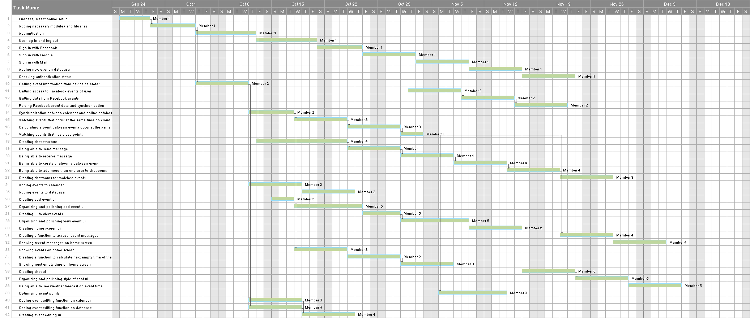



6.Risks

|  |  |  |  |
| --- | --- | --- | --- |
|  | Risk | Probabiltiy | Risk Impact |
| 1. | Wrong time estimation | High | Tolerable |
| 2. | Market development | Low | Serious |
| 3. | Government rule changes | Low | Serious |
| 4. | Privacy Issues | Moderate | Serious |
| 5. | Security Issues | High | Serious |
| 6. | Low communication in team | Moderate | Tolerable |
| 7. | Technological developments | Moderate | Insignificant |
| 8. | Project scope expansions | Low | Tolerable |
| 9. | Steps are not tracked properly | Low | Serious |
| 10. | Wrong budget estimation | Low | Tolerable |

|  |  |  |
| --- | --- | --- |
|  | Risk | Explanation |
| 1. | Wrong time estimation | Faulty time estimation |
| 2. | Market development | Changes in aimed market. For example: another application that functions in a similar way or changes in smart phone industry |
| 3. | Government rule changes | Changes in laws that focuses on getting user data (user events etc.), or using that data. |
| 4. | Privacy Issues | Problems with current laws, with users or with other companies on getting user data (user events etc.) or using that data |
| 5. | Security Issues | Losing data, losing integrity of data or losing data protection. This risk especially has a high probability because our team don’t have security advisors or penetration testers |
| 6. | Low communication in team | Communication and trust issues between team members might interfere with app development. |
| 7. | Technological developments | Changes in used libraries and modules or changes in Firebase service might force us to review written code |
| 8. | Project scope expansions | Pivoting app or a part of app or adding new features to app, according to client or users’ requests |
| 9. | Steps are not tracked properly | Missing deadlines, and staying behind schedule |
| 10. | Wrong budget estimation | Estimating the budget with an error |